Name: Priyanshu Tripathi
Roll number: 12022005

Subject: Java Programming
Code: CSPC-23
Assignment 2
INDEX
S. No. | Content | Page No.
1 | Valid Identifiers | 3
2 | Display HI in large block letters | 4
3 | Metric converter | 5
4 | Value of coins | 6
5 | Commas to colons | 7
6 | Determine the range | 8
7 | Random class | 9
8 | Password Generation | 10
9 | Trigonometric values of generated number | 11
10 | Number of goals | 12
11 | Duration test | 13
12 | Guessing game | 15
13 | Rock paper scissor | 17
14 | Count the occurrence of vowels in a string | 19
15 | Pad | 21
16 | Find the sum of even numbers | 22
17 | Splice | 23
18 | Sales person | 24
19 | Sales team | 26

1. Valid Identifiers
Which of the following are valid Java identifiers?
a. Remainder
b. 9_multiple
c. addTwoIntegers
d. PI_VALUE
e. highestof3
f. sum&product
g. diff_&_div

> Remainder
> addTwoIntegers
> PI_VALUE
> highestof3

2. Display HI in large block letters
Write a program that displays the word “HI” in large block letters. Make each large letter out of the other character as shown below:
I I I I I I H H H H H H H H H
I I I I I I H
I I I I I I H
I I I I I I H
I I I I I I I I I H
I I I I I I H
I I I I I I H
I I I I I I H
I I I I I I H H H H H H H H H

public class foobar {

public static void main(String[] args) {
for(int i = 0; i < 9; i++)
switch (i) {
case 0:
case 8: System.out.println("III III HHHHHHHHH");
break;
case 4: System.out.println("IIIIIIIIIIIII H");
break;
default:
System.out.println("III III H");
}
}
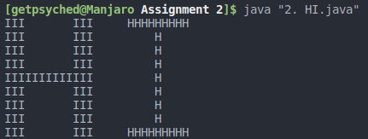
}

3. Metric Converter
Write a program that reads values representing the weight in kilograms, grams, and milligrams and then prints the equivalent weight in milligrams. (For example, 1 kilogram, 50 grams, and 42 milligrams is equivalent to 10,50,042 milligrams.)
import java.util.Scanner;

public class foobar {

public static void main(String[] args) {
Scanner scanner = new Scanner(System.in);

System.out.print("Enter the weight --> ");
int kg = scanner.nextInt();
int g = scanner.nextInt();
int mg = scanner.nextInt();

String string = "";

if (kg > 0)
string += kg > 1 ? kg + " kilograms, " : kg + " kilogram, ";
if (g > 0)
string += g > 1 ? g + " grams, " : g + " gram, ";
if (mg > 0)
string += mg > 1 ? mg + " milligrams " : mg + " milligram ";

System.out.println(String.format("%sis equivalent to %d milligrams", string, convertToMg(kg, g, mg)));
}

public static int convertToMg(int kg, int g, int mg) {
// Changes the value to 0 if entered value is negative
kg = kg < 0 ? 0 : kg*1000000;
g = g < 0 ? 0 : g*1000;
mg = mg < 0 ? 0 : mg;

return kg + g + mg;
}
}
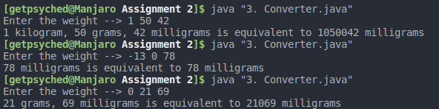

Ignores negative and 0 values ^

4. Value of coins
Write a program that determines the value of the coins in a jar and prints the total in dollars and cents. Read integer values that represent the number of quarters, dimes, nickels, and pennies.
import java.util.Scanner;

public class foobar {

public static void main(String[] args) {
Scanner scanner = new Scanner(System.in);

System.out.print("Enter the number of quarters, dimes, nickels and pennies --> ");
int quarters = scanner.nextInt();
int dimes = scanner.nextInt();
int nickels = scanner.nextInt();
int pennies = scanner.nextInt();

int cents = 0;
cents += quarters < 0 ? 0 : quarters*25;
cents += dimes < 0 ? 0 : dimes*10;
cents += nickels < 0 ? 0 : nickels*5;
cents += pennies < 0 ? 0 : pennies;

int dollars = cents/100;
cents -= dollars*100;

System.out.println("\nValue --> " + dollars + " dollars, " + cents + " cents");
}
}
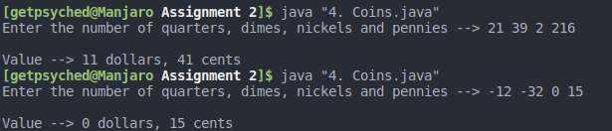

Ignores negative and 0 values ^

5. Commas to colons
Write a line of code that changes all commas(,) in a String names sentence into colons(:). Store the modified String in a new variable named corrected.
import java.util.Scanner;

public class foobar {

public static void main(String[] args) {
Scanner scanner = new Scanner(System.in);

System.out.print("Enter the string --> ");
String string = scanner.nextLine();

System.out.println("\nCorrected string --> " + correctString(string));
}

public static String correctString(String s) {
String corrected = "";
for (int i = 0; i < s.length(); i++)
corrected += s.charAt(i) == ',' ? ':' : s.charAt(i);
return corrected;
}
}
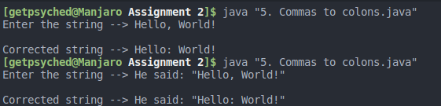

6. Determine the range
Assuming that a Random object has been created called generator, what is the range of the result
of each of the following expressions?
a. generator.nextInt(20)
b. generator.nextInt(8) + 1
c. generator.nextInt(12) + 2
d. generator.nextInt(35) + 10
e. generator.nextInt(100) – 50

a) Range: 0 to 19
b) Range: 1 to 8
c) Range: 2 to 13
d) Range: 10 to 44
e) Range: -50 to 49

7. Random class
Write code to declare and instantiate an object of the Random class (call the object reference
variable rand). Then write a list of expressions using the nextInt method that generates random
numbers in the following specified ranges, including the endpoints. Use the version of the
nextInt method that accepts a single integer parameter.
a. 0 to 10
b. 0 to 400
c. 1 to 10
d. 1 to 400
e. 25 to 50
f. -10 to 15

import java.util.Random;

public class foobar {
public static void main(String[] args) {
Random rand = new Random();

System.out.println(rand.nextInt(11));
System.out.println(rand.nextInt(401));
System.out.println(rand.nextInt(10) + 1);
System.out.println(rand.nextInt(400) + 1);
System.out.println(rand.nextInt(26) + 25);
System.out.println(rand.nextInt(26) - 10);
}
}
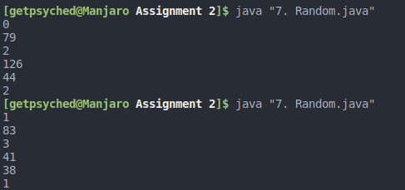

8. Password Generation
Write a program that generates a random password that meets certain criteria. The password should
start with 7 or 8 or 9, and the next five digits can be any digit from 0 to 9. This should be followed
by a dash (-) and then three random uppercase letters. Hint: The integers from 65 to 90 represent
the uppercase letters from A to Z. You can cast an integer to a char type like this: (char)65
is ‘A’ and (char)66 is ‘B’

import java.util.Random;

public class foobar {
public static void main(String[] args) {
String password = "";
Random rand = new Random();

password += rand.nextInt(3) + 7;
for(int i = 0; i < 5; i++)
password += rand.nextInt(10);
password += "-";
for(int i = 0; i < 5; i++)
password += (char)(rand.nextInt(27) + 65);

System.out.println("Password --> " + password);
}
}
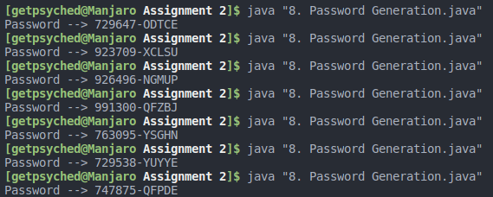

9. Trigonometric values of generated number
Write a program that generates a random integer in the range 20 to 40, inclusive, and displays the
sine, cosine, and tangent of that number.

import java.util.Random;
import java.lang.Math;

public class foobar {
public static void main(String[] args) {
Random rand = new Random();
int number = rand.nextInt(21) + 20;

double sin = Math.sin(number);
double cos = Math.cos(number);
double tan = Math.tan(number);

System.out.println("Generated number is --> " + number);
System.out.println("Sine --> " + sin);
System.out.println("Cosine --> " + cos);
System.out.println("Tangent --> " + tan);
}
}
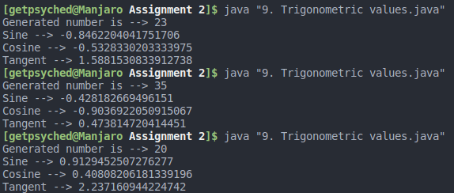

10. Number of goals
Write a class called NumberOfGoals that represents the total number of goals scored by a
football team. The NumberOfGoals class should contain a single integer as instance data,
representing the number of goals scored. Write a constructor to initialize the number of goals to
zero. Write a method called setGoal that increments the value by one whenever a goal is scored,
and another method called getGoal that returns the total number of goals scored so far. Finally,
create a driver class called GoalTracker that creates a few NumberOfGoals objects and tests
their methods.

public class GoalTracker {
public static void main(String[] args) {
NumberOfGoals obj1 = new NumberOfGoals();
NumberOfGoals obj2 = new NumberOfGoals();

System.out.println("Initial values --> " + obj1.getGoal() + " " + obj2.getGoal());
obj1.setGoal(); obj2.setGoal();
System.out.println("After 1st iteration --> " + obj1.getGoal() + " " + obj2.getGoal());
obj1.setGoal();
System.out.println("After 2nd iteration --> " + obj1.getGoal() + " " + obj2.getGoal());
obj2.setGoal(); obj2.setGoal();
System.out.println("After 3rd iteration --> " + obj1.getGoal() + " " + obj2.getGoal());
}
}

class NumberOfGoals {
int goals;

NumberOfGoals() { goals = 0; }
void setGoal() { goals++; }
int getGoal() { return goals; }
}
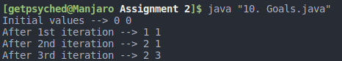

11. Duration test
Write a class called Duration that represents a duration of time in hours and minutes. It should
contain instance data that represents the start hour, end hour, start minute, and end minute. Define
the Duration constructor to accept and initialize all instance data. Include getter and setter methods
for all instance data. Include a toString method that returns a String in the format
[HH:MM,HH:MM]. Write a method called length that returns the length of the duration in minutes.
Assume that a 24-hour format is used for all durations of time and no duration will span over
multiple days. Create a driver class called DurationTest, whose main method instantiates and
updates several Duration objects.

public class DurationTest {
public static void main(String[] args) {
Duration dr = new Duration(02, 50, 4, 50);
assert dr.length() == 120;
for (int i = 0; i < 24; i++) {
Duration dri = new Duration(0, 0, i, 50);
assert dri.length() == i * 60 + 50;
dri.setEndHr(i / 2);
assert dri.length() == i / 2 * 60 + 50;
dri.setEndMin(i);
assert dri.length() == i / 2 * 60 + i;
dri.setStartHr(i / 3);
assert dri.length() == i / 2 * 60 + i - i / 3 * 60;
}
}
}

class Duration {
int startHr;
int startMin;
int endHr;
int endMin;

public Duration(int startHr, int startMin, int endHr, int endMin) {
this.startHr = startHr;
this.startMin = startMin;
this.endHr = endHr;
this.endMin = endMin;
}

public int length() {
return 60 * (endHr - startHr) + (endMin - startMin);
}

@Override
public String toString() {
return String.format("[%02d:%02d, %02d:%02d]", startHr, startMin, endHr, endMin);
}

public int getStartHr() { return startHr; }

public int getStartMin() { return startMin; }

public void setStartHr(int startHr) { this.startHr = startHr; }

public void setStartMin(int startMin) { this.startMin = startMin; }

public int getEndHr() { return endHr; }

public int getEndMin() { return endMin; }

public void setEndHr(int endHr) { this.endHr = endHr; }

public void setEndMin(int endMin) { this.endMin = endMin; }
}
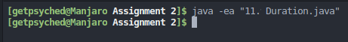

No AssertionError raised

12. Guessing game
Write a program that plays the Hi-Lo guessing game with numbers. The program should pick a
random number between 1 and 100 (inclusive), then repeatedly prompt the user to guess the
number. On each guess, report to the user that he or she is correct or that the guess is high or low.
Continue accepting guesses until the user guesses correctly or chooses to quit. Use a sentinel value
to determine whether the user wants to quit. Count the number of guesses and report that value
when the user guesses correctly. At the end of each game (by quitting or a correct guess), prompt
to determine whether the user wants to play again. Continue playing games until the user chooses
to stop.

import java.util.Random;
import java.util.Scanner;

public class foobar {
public static void main(String[] args) {
char playing = 'y';
Scanner sc = new Scanner(System.in);

while (playing == 'y') {
playGame(sc);
System.out.print("Do you want to keep playing? [y/n] ");
playing = sc.next().charAt(0);
}
}

static void playGame(Scanner sc) {
char quit;
int answer = new Random().nextInt(101);
int guess, tries = 0;
do {
System.out.print("Choose a number --> ");
guess = sc.nextInt();
if (guess == answer) {
System.out.println("You won in " + tries + " tries!");
break;
}
if (guess < answer)
System.out.println("You guess is too low");
else if (guess > answer)
System.out.println("You guess is too high");

System.out.print("Do you want to quit? [y/n] ");
quit = sc.next().charAt(0);
tries++;
} while (quit == 'n');
}
}
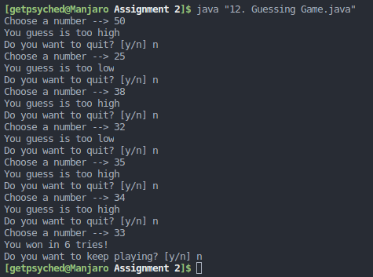

13. Rock paper scissor
Write a program that plays the Rock-Paper-Scissors game against the computer. When played
between two people, each person picks one of three options (usually shown by a hand gesture) at
the same time, and a winner is determined. In the game, Rock beats Scissors, Scissors beats Paper,
and Paper beats Rock. The program should randomly choose one of the three options (without
revealing it), then prompt for the user’s selection. At that point, the program reveals both choices
and prints a statement indicating if the user won, the computer won, or if it was a tie. Continue
playing until the user chooses to stop, then print the number of user wins, losses, and ties.

import java.util.Arrays;
import java.util.Random;
import java.util.Scanner;

public class foobar {
public static void main(String[] args) {
char playing = 'y';
Scanner sc = new Scanner(System.in);

int lost = 0;
int won = 0;
int tie = 0;
while (playing == 'y') {
switch (playGame(sc)) {
case 1: won++;
break;
case -1:
lost++;
break;
case 0: tie++;
break;
}
System.out.print("\nDo you want to keep playing? [y/n] ");
playing = sc.next().charAt(0);
System.out.println();
}

System.out.println("Final stats:" +
"\nWon - " + won +
"\nLost - " + lost +
"\nTie - " + tie + "\n");
}

static String[] choices = {"rock", "paper", "scissor"};

static int playGame(Scanner sc) {
int myChoice = new Random().nextInt(3);

System.out.print("Choose [rock/paper/scissor] --> ");
String userChoice = sc.next();

int userChoiceInt = Arrays.asList(choices).indexOf(userChoice.toLowerCase());
if (userChoiceInt == -1) {
System.out.println("Invalid Choice!");
return -1;
}
System.out.print("I choose " + choices[myChoice] + ", ");

switch (userChoiceInt - myChoice) {
case 1:
case -2:
System.out.println("You win!");
return 1;

case -1:
case 2: System.out.println("You lose");
return -1;

case 0: System.out.println("Tie");
return 0;
default:
return 0;
}
}
}
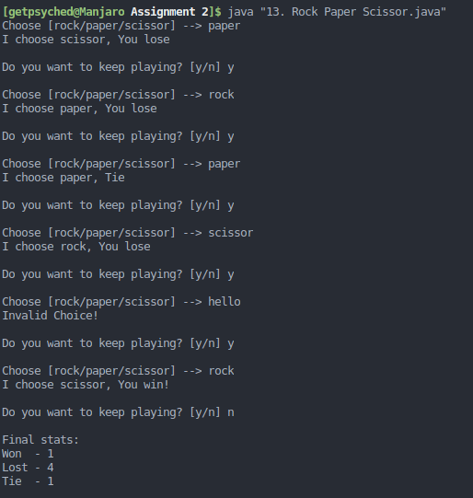

14. Count the occurrence of vowels in a string
Write a program that reads a string from the user, then determines and prints how many of each
lowercase vowel (a, e, i, o, and u) appear in the entire string. Have a separate counter for each
vowel. Also count and print the number of non-vowel characters.

import java.util.*;

public class vowels {
public static void main(String[] args) {
Scanner sc = new Scanner(System.in);

System.out.print("Enter a string --> ");
String input = sc.nextLine();
sc.close();

int a = 0;
int e = 0;
int i = 0;
int o = 0;
int u = 0;

int nonVowel = 0;

for (int i = 0; i < input.length(); i++) {
char ch = input.charAt(i);
switch (ch) {
case 'a':
a++;
break;
case 'e':
e++;
break;
case 'i':
i++;
break;
case 'o':
o++;
break;
case 'u':
u++;
break;

case 'A':
case 'E':
case 'I':
case 'O':
case 'U':
break;

default:
if (Character.isLetter(ch))
nonVowel++;
}
}
System.out.println("a = " + a);
System.out.println("e = " + e);
System.out.println("i = " + i);
System.out.println("o = " + o);
System.out.println("u = " + u);
System.out.println("Non vowels = " + nonVowel);
}
}
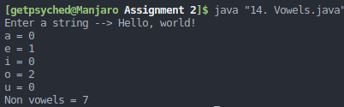

15. Pad
Write a method called pad that accepts a string called str and an integer called length. Return
a string with length number of characters by adding an appropriate number of ‘0’ characters to the
end of the string. If the string is longer than length, then return the original string unchanged. For
example, pad (“aaa”,6) will return “aaa000”.

import java.util.*;

public class foobar {
public static void main(String[] args) {
Scanner sc = new Scanner(System.in);

System.out.print("Enter a string --> ");
String input = sc.nextLine();
System.out.print("Enter length --> ");
int length = sc.nextInt();
sc.close();

String padded = pad(input, length);
System.out.println("Padded String is --> " + padded);
}

public static String pad(String s, int length) {
if (length < s.length())
return s;

return s + "0".repeat(length - s.length());
}
}
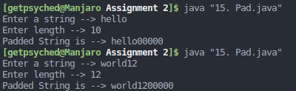

16. Find the sum of even numbers
Write a program that reads an integer value and prints the sum of all even integers between 2 and
the input value, inclusive. Print an error message if the input value is less than 2. Prompt
accordingly.

import java.util.Scanner;

public class foobar {
public static void main(String[] args) {
Scanner sc = new Scanner(System.in);

System.out.print("Enter a number --> ");
int num = sc.nextInt();
sc.close();

if (num < 2) {
System.out.println("Invalid number!");
return;
}

int sum = 0;
for (int i = 2; i <= num; i += 2)
sum += i;

System.out.println("Sum --> " + sum);
}
}
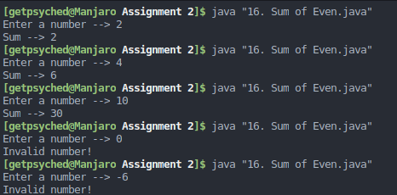

17. Splice
Write a method called splice that takes a String and two integers named startingIndex and
deletelength. Remove deleteLength characters from the String, starting with index
startingIndex. Return the resulting string. If startingIndex is less than 0, then start
removing characters from index 0. If deleteLength is 0, then return the original string.

import java.util.Scanner;

public class foobar {
public static void main(String[] args) {
Scanner sc = new Scanner(System.in);

System.out.print("Enter a string --> ");
String str = sc.nextLine();
System.out.print("Enter start index --> ");
int startingIndex = sc.nextInt();
System.out.print("Enter delete count --> ");
int deleteLength = sc.nextInt();

String string = splice(str, startingIndex, deleteLength);

System.out.println("Result is " + string);
}

public static String splice(String str, int start, int del) {
if(start < 0)
start = 0;
return str.substring(0, start) + str.substring(start + del);
}
}
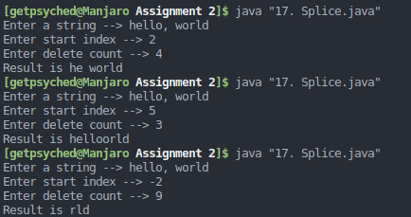

18. Sales person
Create a class called SalesPerson that represents a salesperson in an organization. The
SalesPerson class should have the name, the phone number, and the assigned district of a
salesperson. Each salesperson acquires a certain sale amount every day. Provide a constructor that
sets all instance values based on parameter values. Overload the constructor such that each daily
sale amount for a week is set to zero. Provide a method called setDailyAmount that accepts a
day of a week as a number (0 for Sunday, 1 for Monday, and so on) and an amount and sets that
amount as the daily sale amount. Provide another method called getDailyAmount that accepts
a day of a week and returns the amount for that day. Provide a method called total that calculates
the total sale amount for the week a method called average that calculates the average daily sale
amount for the week. Write a toString method that prints all the details of the salesperson.
Write a toString method that prints all the details of the salesperson. Write a driver class to
exercise the SalesPerson class.

import java.util.*;

public class foobar {
public static void main(String[] args) {
SalesPerson sp = new SalesPerson("someName", "9999999999", "someDistrict");
sp.setDailyAmount(0, 1000);
sp.setDailyAmount(1, 2000);
sp.setDailyAmount(2, 3000);
sp.setDailyAmount(3, 4000);
sp.setDailyAmount(4, 5000);

assert sp.getDailyAmount(2) == 3000;
assert sp.getDailyAmount(4) == 5000;

assert sp.total() == 15000;
assert (int)sp.avg() == (int)(15000/7);

System.out.println("All tests passed");
}
}

class SalesPerson {
String name;
String phoneNum;
String district;
int[] sales;

public SalesPerson(String name, String phoneNum, String district) {
this.name = name;
this.phoneNum = phoneNum;
this.district = district;
sales = new int[] {0, 0, 0, 0, 0, 0, 0};
}

public int getDailyAmount(int day) { return sales[day]; }

public void setDailyAmount(int day, int amt) { this.sales[day] = amt; }

public int total() {
int sum = 0;
for (int val : sales)
sum += val;
return sum;
}

public double avg() { return total() / 7.0; }

@Override
public String toString() {
return "\nName --> " + name + "\nDistrict --> " + district +
"\nPhone --> " + phoneNum + "\nTotal sales --> " + total();
}
}
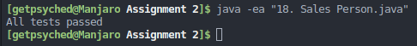

19. Sales team
Write a class called SalesTeam that represents a team of salespeople. Each salesperson on the
team is represented by the SalesPerson class as in the previous question. Each team has a name,
and the constructor needs only to accept the name of the team. Use and ArrayList to store the
team members. Provide a method called addSalesPerson that accepts a SalesPerson
object. Provide a method called weeklyReport that prints the name and the total sale amount
of each team member and the total amount for the entire team. Write a driver class that fully
exercise the SalesTeam class.

import java.util.*;

public class foobar {
public static void main(String[] args) {
SalesTeam team = new SalesTeam("team");

SalesPerson sp = new SalesPerson("someName", "9999999999", "someDistrict");
sp.setDailyAmount(0, 1000);
sp.setDailyAmount(1, 2000);
sp.setDailyAmount(2, 3000);
sp.setDailyAmount(3, 4000);
sp.setDailyAmount(4, 5000);

assert sp.getDailyAmount(2) == 3000;
assert sp.getDailyAmount(4) == 5000;

assert sp.total() == 15000;
assert (int)sp.avg() == (int)(15000/7);

team.addSalesPerson(sp);
team.weeklyReport();
System.out.println("All tests passed");
}
}

class SalesTeam {
ArrayList<SalesPerson> members;
String name;

public SalesTeam(String name) {
this.name = name;
members = new ArrayList<>();
}

public void addSalesPerson(SalesPerson p) { members.add(p); }

public void weeklyReport() {
System.out.println("Sales team --> " + name);
int sales = 0;
for (SalesPerson per : members)
sales += per.total();

System.out.println("Total sales --> " + sales);

for (SalesPerson per : members)
System.out.println(per.toString());
}
}

class SalesPerson {
String name;
String phoneNum;
String district;
int[] sales;

public SalesPerson(String name, String phoneNum, String district) {
this.name = name;
this.phoneNum = phoneNum;
this.district = district;
sales = new int[] {0, 0, 0, 0, 0, 0, 0};
}

public int getDailyAmount(int day) { return sales[day]; }

public void setDailyAmount(int day, int amt) { this.sales[day] = amt; }

public int total() {
int sum = 0;
for (int val : sales)
sum += val;
return sum;
}

public double avg() { return total() / 7.0; }

@Override
public String toString() {
return "\nName --> " + name + "\nDistrict --> " + district +
"\nPhone --> " + phoneNum + "\nTotal sales --> " + total();
}



